**Empowering Industries with Radioisotope-Driven Automation Enhancing Efficiency, Safety, and Resilience**

**Preface**

**TABLE OF CONTENTS**

**1. SOFTWARE DEVELOPMENT LIFE CYCLE**

**2. PLATFORM KNOWLEDGE**

**3. DOMAIN KNOWLEDGE**

3.1 METHODS

**4. ABOUT THE PROJECT**

4.1 ABSTRACT

4.2 SCOPE OF THE PROJECT

4.3 EXISTING SYSTEM

  4.3.1 DISADVANTAGES

     4.4 PROPOSED SYSTEM

  4.4.1 ADVANTAGES

**5. BOTTOM LINE AND FUTURE ENHANCEMENT**

**6. HARDWARE AND SOFTWARE REQUIREMENTS**

**1. SDLC (Software Development Life Cycle)**

The Software Development Life Cycle is a systematic process for building software that ensures the quality and correctness of the software built. SDLC process aims to produce high-quality software which meets customer expectations. The software development should be completed within the pre-defined time frame and cost.

**SDLC Phases**

The entire SDLC process is divided into the following stages:

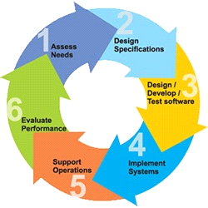

* Phase 1: Requirement collection and analysis
* Phase 2: A feasibility study
* Phase 3: Design
* Phase 4: Coding
* Phase 5: Testing
* Phase 6: Installation/Deployment
* Phase 7: Maintenance

**2. Platform Knowledge**

**Introduction to Python:**

Python is developed by Guido van Rossum. Guido van Rossum started implementing Python in 1989. Python is a facile programming language so even if you are new to programming, you can learn python without facing any issues. Python is a general-purpose programming language that is becoming ever more popular for data science. Companies worldwide are using Python to harvest insights from their data and gain a competitive edge. Python specifically for data science. To store and manipulate data, and helpful data science tools to begin conducting your analyses.

**What is Python?**

Python is an interpreted, high-level, general-purpose programming language. It is dynamically typed and collected. Python is an interpreted language and not a compiled one, although compilation is a step. Python code, written in **.py** file is first compiled to what is called byte code which is stored with a **.**pyc or **.**pyo format. Instead of translating source code to machine code like C++, Python code it translated to byte code. This byte code is a low-level set of instructions that can be executed by an interpreter.  One popular advantage of interpreted languages is that they are platform-independent. As long as the Python byte code and the Virtual Machine have the same version, Python byte code can be executed on any platform (Windows, MacOS, etc). Dynamic typing is another advantage. In static-typed languages like C++, you have to declare the variable type and any discrepancy like adding a string and an integer is checked during compile time*.* In older programming languages, memory allocation was quite manual. Many times when you use variables that are no longer in use or referenced anywhere else in the program, they need to be cleaned from the memory. Garbage Collector does that for you.

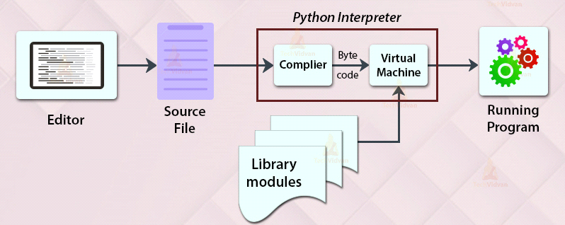

**3. Domain**

**Deep Learning**

Deep learning is a subset of machine learning in artificial intelligence (AI) that has networks capable of learning unsupervised from data that is unstructured or unlabelled. Also known as deep neural learning or deep neural network. Deep learning is a particular kind of machine learning that achieves great power and flexibility by learning to represent the world as a nested hierarchy of concepts, with each concept defined in relation to simpler concepts, and more abstract representations computed in terms of less abstract ones.

Deep Neural Network – It is a neural network with a certain level of complexity (having multiple hidden layers in between input and output layers). They are capable of modelling and processing non-linear relationships.

Deep Belief Network (DBN):

It is a class of Deep Neural Network. It is multilayer belief networks.

Steps for performing DBN:  
 a. Learn a layer of features from visible units using Contrastive Divergence algorithm.

b. Treat activations of previously trained features as visible units and then learn features of features.

c. Finally, the whole DBN is trained when the learning for the final hidden layer is achieved.

Recurrent (perform same task for every element of a sequence) Neural Network – Allows for parallel and sequential computation. Similar to the human brain (large feedback network of connected neurons). They are able to remember important things about the input they received and hence enables them to be more precise.

Deep learning drives many [artificial intelligence (AI)](https://www.ibm.com/topics/artificial-intelligence) applications and services that improve automation, performing analytical and physical tasks without human intervention. Deep learning technology lies behind everyday products and services (such as digital assistants, voice-enabled TV remotes, and credit card fraud detection) as well as emerging technologies.

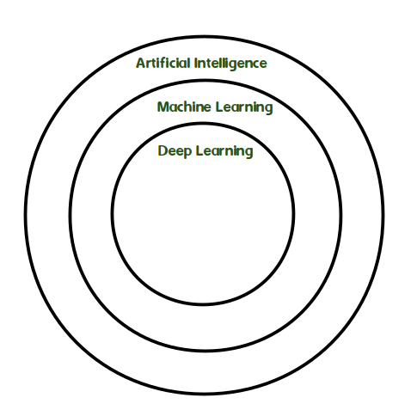

Machine learning is an application of Artificial Intelligence (AI) that provides systems the ability to automatically learn and improve experience without being explicitly programmed. Machine learning focuses on the development of computer programs that can access data and use it learn for themselves. The primary aim is to allow the computer to learn automatically without human intervention or assistance and adjust actions accordingly.

The test for a machine learning model is a validation error on new data not a theoretical test that proves a null hypothesis. Because this often uses an iterative approach to learn from data, the learning can be easily automated.

**4. About the project:**

**4.1 Abstract:**

Prediction methods play a crucial role in industries by leveraging data to make accurate forecasts and informed decisions. In manufacturing, predictive models are employed to optimize production processes, minimize downtime, and prevent equipment failures. By analyzing historical data and real-time sensor readings, these models can anticipate maintenance needs and schedule repairs proactively, leading to improved efficiency and cost savings These predictive capabilities lead to improved efficiency, cost savings, enhanced customer satisfaction, and a competitive edge in the market..So in out project paper proposes that, Due to their high accuracy potential, these predictive methods are primarily classification techniques in machine learning; therefore, in our project, we use one of these classification techniques to predict the necessary isotope in businesses and secure the data using an encryption standard system.

**4.2 Scope of the project:**

By utilizing data to provide precise projections and educated judgements, prediction methods play a significant role in a variety of businesses. Predictive models are used in manufacturing to enhance workflows, cut downtime, and avoid equipment breakdowns. These models can predict maintenance requirements and plan repairs proactively by examining previous data and current sensor readings, which improves efficiency and lowers costs. These predictive skills boost productivity, reduce costs, increase customer happiness, and provide businesses a competitive edge. So, in order to predict the required isotope for the client purpose, we use a classification technique and boosting algorithm called Gradient Boosting Classifier, which is considered a high accuracy algorithm. Once the isotope is processed successfully, it is sent to the technical team, who secure the data using encryption standard system (RSA).

**4.3 Existing system:**

Through the use of data to provide precise projections and informed judgements, prediction methods play a key role in various industries. Predictive modelling is used in manufacturing to enhance production procedures, reduce downtime, and avoid equipment breakdowns. These models can foresee maintenance requirements and schedule repairs in advance by examining previous data and current sensor readings, which improves efficiency and lowers costs. As a result, although the adpative metric method, a previously popular predictive technique, has some significant shortcomings like increased complexity, increased sensitivity to noise, and a slower rate of prediction due to outliers,

**4.3.1 Disadvantages:**

• **Lack of accurate data** – metric methods easy and fast results but the result are

More approximate

**. Lack of analytic capabilities-** data got from analytics results in less efficiency.

. **Uncertain-** output from recommendation system not given certain results for the user

. **Cold-start problem-** the difficulty of making predictive when the users or the data’s are new.

**4.4 Proposed system:**

Our project has a gradient boosting classifier, which is employed to achieve our project goals, because predictive concept classification methods typically deliver better results.Gradient Boosting is a powerful machine learning algorithm that offers several advantages for various applications**.**A recommended solution using a regression algorithm which is gradient boosting algorithm which is often provides more accuracy and flexible while comparing to the previous method mentioned, getting a relevant data from the project team and analyze and provide a solution lead to complete a project within a time and report will be used to avoid the mistakes in the future. It can be used in various fields and for various purposes.

**Advantages:**

### Lower Work and Overhead- predict solutions to make it easier to complete work

* **Customer Satisfaction**-faster work can make the customer more satisfied and tends to more order
* **Provide useful Reports- output results after recommendation makes to avoid mistakes in future**
* **Time efficient-** the provided result helps solve the problem quick and efficient helps in less time consuming and provide more efficient time
* **Deliver relevant content-** the data is collected in real time so the reactiveness is probably high

**5. BOTTOM LINE AND FUTURE ENHANCEMENT:**

In this project, a general study of the performance of recommender systems is conducted. There are many different recommendation algorithms proposed to meet the requirement of discovering preferred items in a large information space Hence the recommendation system is generally classified into three content based method, collaborative filtering methods and hybrid method. In this project we used one of the well-known classifier algorithm Gradient booster will helps in finding the predictive measures and filtering techniques and provide without lags and foremost solutions but it does some have overemphasize outliers and cause over fitting in future we can remove those drawbacks will be used for some more applications , May the data inaccuracy the result may Vary, So it is important to enhancement the data analysis and can lead to usage of recommended system in various domains in the various industries.











































**6. System Requirement;**

**Hardware requirements:**

* Processor: Intel (R) Pentium (R)
* Speed: 1.6 GHz and Above
* RAM: 4 GB and Above
* Hard Disk: 120 GB
* Monitor: 15’’ LED SVGA
* Input Devices: Keyboard, Mouse

**Software requirements:**

* Operating system: Windows 7 / 8 / 8.1 / 10
* Coding Language: PYTHON
* IDE: PyCharm
* Database: MySQL